

**FACULTY OF ENGINEERING AND BUILT ENVIRONMENT**

**Department of Mechanical, Industrial and Electrical Engineering**

**Bachelor of Engineering (B. Eng.) Electronics & Telecommunications Engineering.**

**Electronics & Telecommunications Project 421 (ETP821)**

**ETP****821 Final Year Project Proposal**

**Project topic**

**Radio Frequency Identification (RFID) University Base Smart Library Management System**

Proposal by Armas Angala E

22010225

Supervised by Professor Abolarinwa, Joshua

06-August-2024

# **Contents**

**Introduction** 3

**Problem statement** 5

**Aim** 5

**Objectives** 5

**Project methodology** 7

**Expected outcomes** 11

**Conclusion :** 12

**Reference** 13

# **Introduction**

The efficient management of book borrowing and returning processes is critical for the smooth operation of any library. At the Namibia University of Science and Technology (NUST), the library faces challenges in managing book returns and shelving due to the high volume of transactions and limited staff availability. During open hours, staff are primarily occupied with processing book loans and returns, leaving little time for reshelving books. Consequently, returned books accumulate throughout the day, increasing the workload after hours and delaying the availability of books for other patrons. To address these issues, this project proposes the development of an automated library management system. By integrating RFID technology, automated sorting mechanisms, and user-friendly interfaces, the system aims to streamline the book borrowing and returning processes, reduce staff workload, and enhance overall user satisfaction at the NUST library.

To understand the context and potential impact of implementing such a system, it is essential to review existing literature on automated library systems, RFID technology, and their applications in enhancing library operations. This literature review will provide insights into the current state of library automation, the benefits and challenges associated with RFID implementation, and case studies of similar systems in other institutions.

Abdullah Al, Asrafi Ariddrita, and Howlader Anti Riad Ahmedi in the paper [1] discusses how libraries can benefit from new technologies, specifically the Internet of Things (IoT) and RFID systems. Despite changes in the role of libraries, many remain traditional. RFID-based systems can enhance library management by improving transaction speed, traceability, and security. The paper proposes using RFID for a reference positioning system to quickly locate books and handle borrowing processes, with notifications sent via mobile systems. It addresses challenges in library management and data security, showing improved efficiency and security in an IoT-enhanced library design.

Nikita Shivaji in the paper [2] discusses the evolution and modernization of library management systems, highlighting the challenges of traditional library operations, such as time-consuming processes and high manpower requirements. It introduces the concept of Intelligent Library Management Systems (ILMS), which utilizes AI, GSM, and RFID technologies to streamline operations and enhance user experiences. The paper focuses on integrating emerging technologies beyond RFID, including AI, machine learning, and data analytics, to optimize library services and meet modern user needs. The project demonstrates successful deployment in a college library, showcasing tangible improvements in efficiency and effectiveness.

The paper [3] introduces the applicability of RFID systems in a Smart Library Management System (SLMS). RFID, an advanced Auto Identification and Data Collection technology, automates business processes and identifies numerous tagged items like books using radio waves. Unlike barcode and token card systems, which require line-of-sight and are labor-intensive, RFID is a wireless, non-contact system that improves efficiency. It enhances resource utilization, reduces manual tasks, and boosts security and traceability in libraries, providing both immediate and long-term benefits.

The research [4] aims to design a Smart Library Management System for libraries in Oman, addressing issues like data loss, slow transactions, and difficulty updating information. The current system is inadequate, prompting the need for a new RFID and IoT-based solution. The proposed system will streamline library operations, benefiting staff and students by efficiently managing and controlling library information. The research is based on requirements gathered at Middle East College, Muscat, Oman, ensuring the system addresses local library needs effectively

The paper [5] discusses how technology, particularly the concept of the "Smart Library," is transforming library services as part of the broader "Smart City" initiative. Smart libraries integrate digital processes to create more efficient, flexible, and sustainable environments. They offer advanced services like computer-aided design, knowledge mining, and personalized services through mobile devices and IoT-based systems. The paper highlights the architecture of smart libraries and various IoT and ICT services, such as RFID, Cloud computing, and Magic Mirrors, emphasizing innovation to reach users effectively.

The paper [6]outlines the importance of libraries and the challenges faced by traditional systems. The project aims to use RFID technology to improve book management by tracking tagged books with radio waves. The system allows students to check book availability and manage borrowing processes efficiently. Notifications about due dates are sent via GSM, and fines are generated for late returns. Additionally, an RFID EAS system is implemented for theft detection, enhancing the overall security and efficiency of library operations.

The paper [7]highlights the inefficiencies in traditional library operations, where manual tracking is prevalent. The proposed Library Management System (LMS) aims to automate and streamline these operations using RFID technology. Books will have RFID tags, and librarians will use RFID readers, all integrated into a user-friendly software interface. The system will ensure data integrity and security with a local MySQL server. The focus is on cost-effectiveness and improved accuracy, modernizing library operations and enhancing the borrowing and returning process for users.

The paper[8] highlights the challenges faced by library staff and users in managing tasks like sorting, lending, and borrowing books. It proposes a smart library management system using RFID technology to address these issues. By implementing low-cost passive RFID tags, libraries can significantly reduce modernization costs. This integration streamlines operations, making tasks easier, smarter, more convenient, and practical for both staff and users.

The paper [9]discusses how libraries have not significantly evolved despite technological advances, while their roles have changed. It highlights the potential of the Internet of Things (IoT) and radio-frequency identification (RFID) systems to enhance library services. An RFID-based library management system can improve transaction flow, traceability, and security. The system includes a reference positioning system to facilitate quick searches and reduce the burden on librarians. RFID and Global System for Mobile (GSM) technologies address issues in library management and data security, improving efficiency and security.

The project described in [10]outlines an IoT-based RFID Attendance System using the ESP32 microcontroller. This system aims to improve the attendance process in schools and offices by using RFID technology to read card data and send it to a web server via Wi-Fi. The project includes a PHP, CSS, and JavaScript web interface that allows for secure login, user management, and tracking of attendance. Administrators can manage users and devices, and attendance data can be exported to Excel, enhancing the accuracy and convenience of attendance management through IoT and RFID technologies.

# **Problem statement**

The library at the Namibia University of Science and Technology (NUST) faces significant operational challenges in managing book returns and shelving. During open hours, library staff are primarily occupied with processing book loans and returns, leaving little time for reshelving books. As a result, returned books accumulate throughout the day, necessitating additional time and effort from the staff after closing hours to ensure that all books are returned to their proper locations. This not only increases the workload for library staff but also delays the availability of returned books for other patrons, reducing the overall efficiency of library operations and affecting user satisfaction. An automated solution is needed to streamline the process of returning and shelving books, allowing library staff to focus on assisting patrons and maintaining the library's overall efficiency.

# **Aim**

To develop an automated library management system that enhances the efficiency of book borrowing and returning processes at the NUST library, reducing the workload on staff and improving user satisfaction.

# **Objectives**

1. Design and Implement RFID-Based Book Tracking:

Integrate RFID technology to automate the identification and tracking of books during borrowing and returning processes.

1. Develop a User-Friendly Interface:

Create an intuitive user interface that guides students through the borrowing and returning processes using LCD displays and SMS notifications.

1. Automate Book Return Sorting:

Develop a system to automatically sort and categorize returned books into appropriate storage locations using RFID and servo motors.

1. Streamline Student and Book Registration:

Simplify the process of registering new students and books by integrating RFID scanning with a web-based administrative interface.

1. Enhance Communication with Users:

Implement a notification system to send automated SMS messages to students with details of borrowing and returning transactions.

# **Equipment’s**

Following are the Hardware and Software components required for making IoT Based RFID

**Hardware Components**

* RFID Readers (5 units):

Used to scan RFID tags on books and student ID cards for identification and tracking purposes.

* RFID Tags (10 units):

Attached to books and student ID cards to provide unique identifiers for tracking and management.

* Microcontrollers (2 units):

ESP-32 ESP-WROOM-32U Development Board for Arduino:

Used to manage and control the RFID readers, LCDs, and servo motors, providing a central point for processing and communication.

* LCD Display (1 unit):

Used to provide instructions and feedback to users during the borrowing and returning processes, ensuring a smooth user experience.

* Servo Motors (3 units):

Used to automate the opening of book return boxes based on book categories, facilitating the sorting and return process.

* GSM Module (1 unit):

SIM800L GPRS GSM Breakout Module:

Enables sending SMS notifications to students regarding their borrowing and returning transactions, enhancing communication and service.

**software components**

* Embedded C:

Will be used for coding all hardware interface interactions, controlling RFID readers, LCDs, and servo motors.

* PHP:

Will be employed for writing the application logic and developing the web interface for the library management system.

* MySQL:

Will be utilized as the database management system to store and manage book records, student information, and transaction data.

* Apache 2:

Will be the web server used to host and run the PHP-based web interface.

* JavaScript and CSS:

JavaScript will be used to add interactivity and validate forms on the web interface. CSS will be used for styling the web interface, adding animations, and ensuring a responsive design.

# **Project Costs**

| **Component** | **Quantity** |  |  | **Total Cost (NAD)** |
| --- | --- | --- | --- | --- |
| **RFID Readers** | 5 |  |  | NAD 350 |
| **RFID Tags** | 10 |  |  | NAD 135 |
| **Microcontrollers (ESP-32)** | 2 |  |  | NAD 432 |
| **LCD Display** | 1 |  |  | NAD 270 |
| **Servo Motors** | 3 |  |  | NAD 140 |
| **GSM Module (SIM800L)** | 1 |  |  | NAD 126 |
| **Miscellaneous** | - |  |  | NAD 630 |
| **Software** | - |  |  | NAD 0 |
| **Total** | - |  |  | NAD 2,333 |

# **Project methodology**

The methodology section outlines the structured approach and techniques that will be employed to develop the "Prime Smart Library Management System." This section serves as a roadmap for the entire project, ensuring that each phase is executed systematically and effectively. By detailing the processes and tools used, the methodology provides a clear framework for achieving the project’s objectives and delivering a robust, efficient library management solution. It emphasizes the integration of hardware and software components, the importance of iterative testing, and the role of feedback in refining the system. This structured approach is crucial for managing complexities, optimizing resources, and achieving the desired outcomes within the given timeframe.

**Architecture Design**

The overall system architecture for the automated library management system at NUST will integrate various hardware and software components to ensure efficient book borrowing and returning processes. The hardware components will include RFID readers, RFID tags, microcontrollers (ESP32), LCD displays, servo motors, and a GSM module. The RFID readers and tags will be used to uniquely identify and track books and students. The microcontrollers will serve as the central processing units, managing the RFID readers, controlling the LCD displays to provide instructions to users, and operating the servo motors to sort returned books into the correct categories. The GSM module will be responsible for sending SMS notifications to students about their borrowing and returning transactions.

On the software side, the system will consist of a web application developed using PHP for the application logic and MySQL for the database management. The database will store information about books, students, and transactions. The web application will interface with the hardware components through embedded C code running on the microcontrollers, which will handle the interactions between the RFID readers, LCDs, and servo motors. JavaScript and CSS will be used to create a responsive and interactive web interface for administrative tasks, such as adding new books and students to the system.

**User Interface Design**

The user interface design will focus on creating intuitive and user-friendly interactions for both administrators and students. For the administrative web interface, wireframes will include pages for adding books and students to the database. The "Add Book" page will feature input fields for the RFID tag, book title, and category, along with a submit button to update the database. The "Add Student" page will include fields for the RFID tag, student name, and cell phone number, with a similar submission mechanism.

For students, the LCD screens will guide them through the borrowing and returning processes. Initial screens will display a welcome message and prompt students to scan their RFID tags. If a student is not found in the database, the LCD will display a message instructing them to register. If the student is identified, the screen will prompt them to scan the book they wish to borrow. Upon returning a book, the LCD will instruct the student to place the book in the appropriate return box, which will be automated by servo motors and verified by RFID scans within the box.

Figure 1 below shows the workflow of the proposed project.

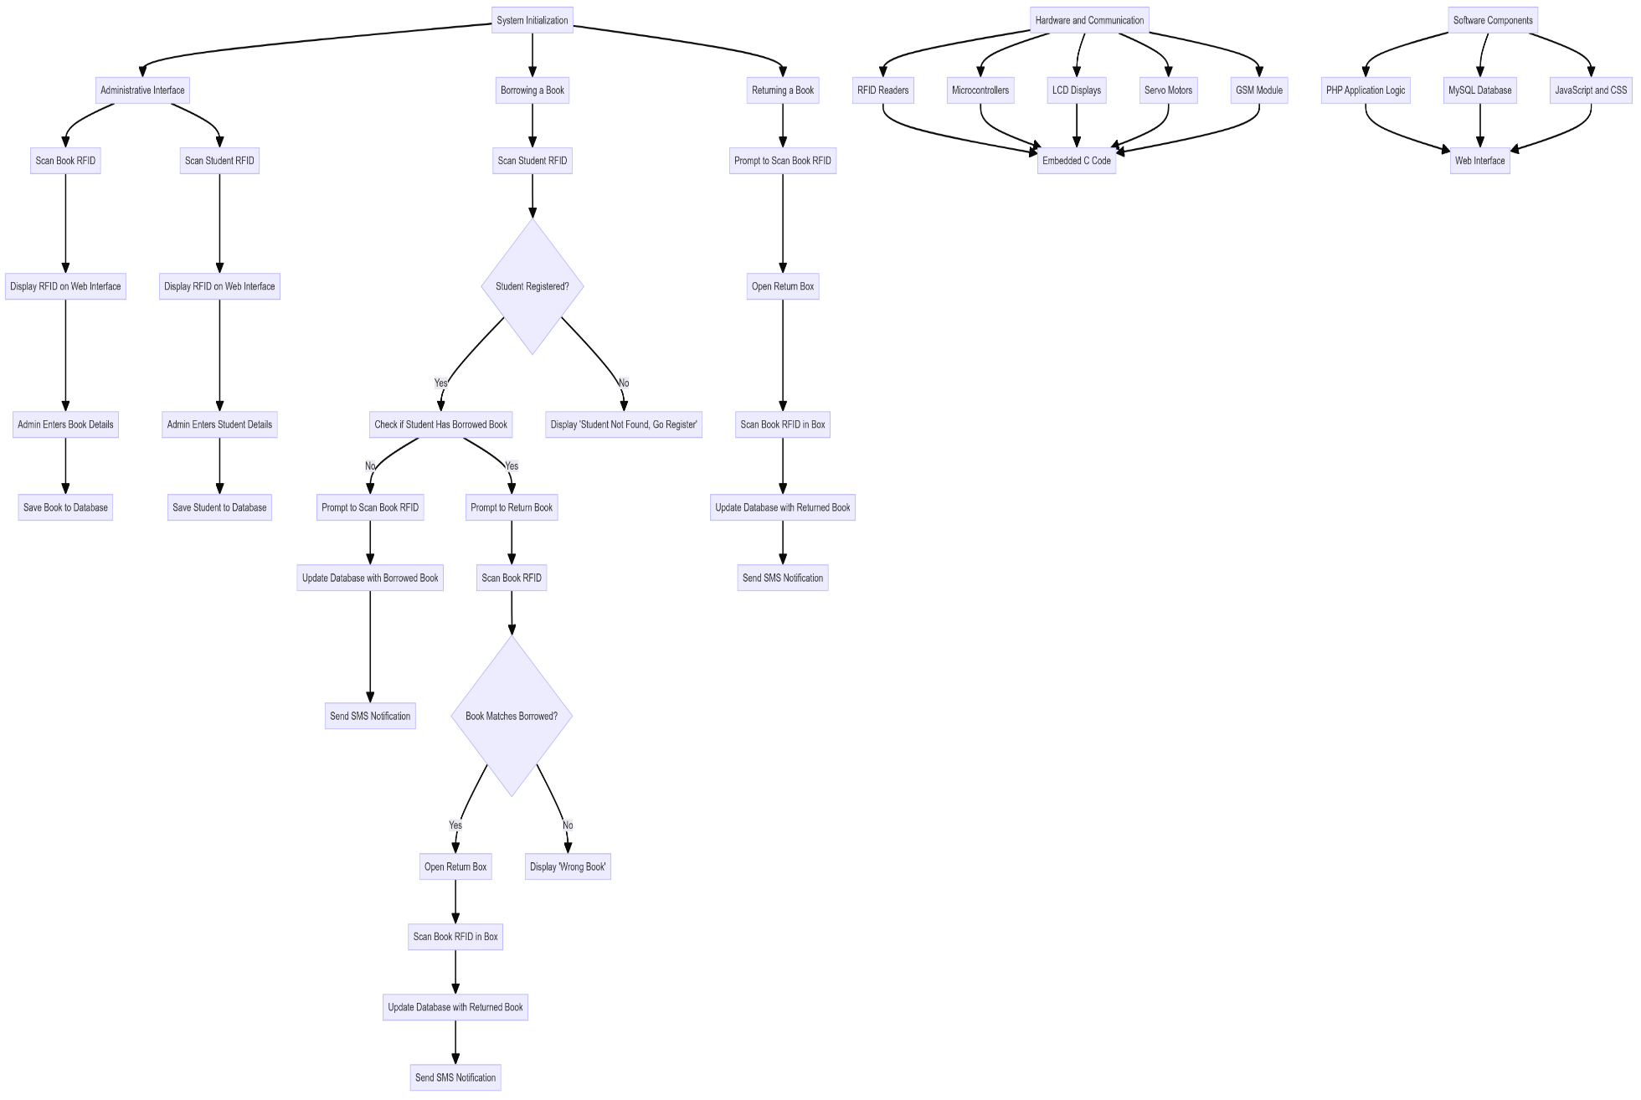

Fig 1

**Hardware Development**

The hardware development phase will involve programming the microcontrollers using embedded C to interface with the RFID readers, LCDs, and servo motors. The microcontrollers will need to read RFID tags and process the data to determine the appropriate actions, such as displaying messages on the LCD screens or activating the servo motors to open the correct return box. The embedded C code will manage these interactions and ensure seamless communication between the hardware components.

**Software Development**

The software development phase will focus on creating the application logic and web interface using PHP. This will include handling form submissions for adding books and students, processing borrowing and returning transactions, and interacting with the MySQL database to update records. The database schema will be designed to efficiently store and retrieve information related to books, students, and transactions. Client-side scripts written in JavaScript will enhance the interactivity of the web interface, while CSS will ensure the interface is visually appealing and responsive.

**Integration and Testing**

The integration phase will involve combining the hardware and software components to ensure they work together as intended. This will include testing the communication between the RFID readers, microcontrollers, and the web application, as well as verifying that the LCD displays and servo motors respond correctly to user actions. Integration testing will identify and resolve any issues in the interactions between the components, ensuring a smooth and reliable system.

**Deployment Preparation**

Deployment preparation will include setting up the Apache 2 server to host the PHP-based web application and configuring the MySQL database. This step will ensure that the web application is accessible, and that the database is properly set up to handle the storage and retrieval of information.

# **Timeframe**

The project timeframe for the "Prime Smart Library Management System" will ensure that each phase is completed systematically and efficiently. The schedule will outline key milestones, starting with initial planning and concluding with the final submission of marks. By following this timeline, the project team will be able to manage resources effectively, address any challenges promptly, and deliver a robust and functional library management system on time. Each stage, from proposal submission to final presentations, will be clearly defined, providing a structured path to achieve the project’s objectives.

Figure 2 below project gun chart

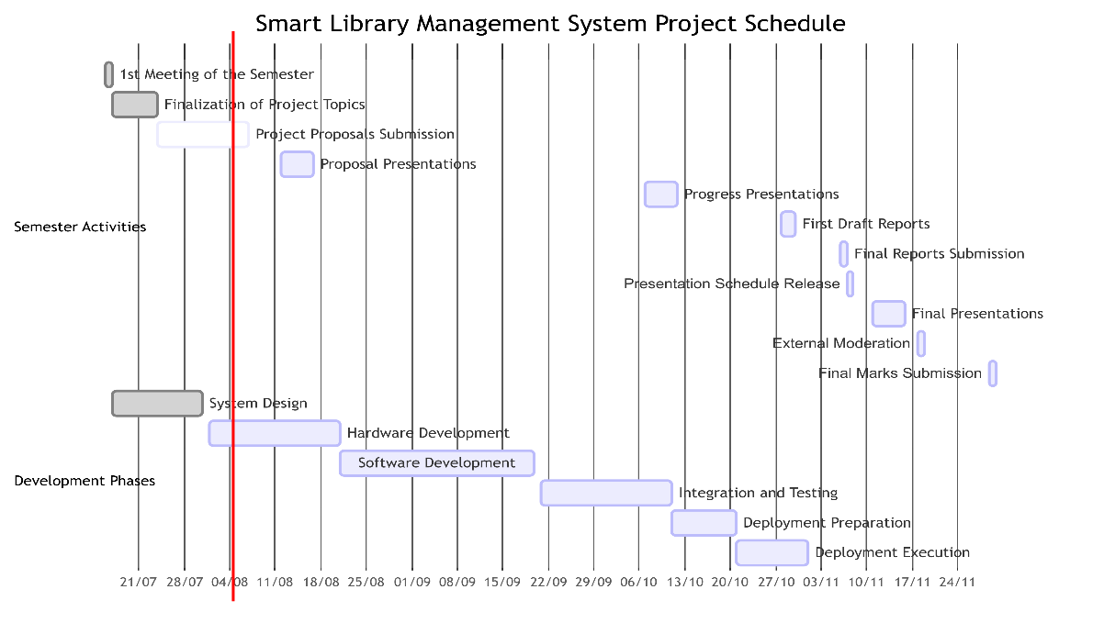

Fig 2

# **Expected outcomes**

The expected outcomes of the "Smart Library Management System" project are multifaceted, aiming to enhance both operational efficiency and user satisfaction at the NUST library. Firstly, the automated system will streamline book borrowing and returning processes, significantly reducing wait times for students and alleviating the workload on library staff. This will allow staff to focus on more critical tasks and improve the overall efficiency of library operations.

The user-friendly interface, combined with clear instructions via LCD displays, will make the borrowing and returning processes intuitive for students. Additionally, SMS notifications will enhance communication by keeping students informed about their transactions, further improving their experience.

Automation will extend to book sorting as well, with the system categorizing and directing returned books to their appropriate storage locations using RFID and servo motors. This will save time and effort for library staff, ensuring that returned books are swiftly available for other patrons. The integration of RFID scanning with a web-based administrative interface will also simplify the registration process for new students and books, enabling library staff to manage records more efficiently and maintain an up-to-date database.

Real-time notifications and updates will be sent via SMS, keeping students informed about their borrowing and returning transactions, thereby reducing the likelihood of overdue books and improving overall resource management. The reduced manual workload for library staff will allow them to focus on assisting patrons and performing other essential duties, leading to a more efficient and well-managed library.

By reducing the time required to process and shelve returned books, the system will increase the availability of books for other patrons, enhancing the overall user experience and ensuring that students have timely access to the resources they need. The modular design of the system will also allow for easy scalability and future expansion, enabling the library to add more RFID readers, tags, and other components as needed. This ensures that the system can grow and adapt to the evolving needs of the library.

Overall, the "Smart Library Management System" is expected to deliver a robust and efficient solution that enhances the operational efficiency of the NUST library, reduces the workload on staff, and significantly improves user satisfaction.

# **Conclusion**

In conclusion, the proposed RFID University-Based Smart Library Management System is poised to address the significant operational challenges faced by the NUST library. By integrating RFID technology with automated sorting mechanisms and user-friendly interfaces, the system aims to streamline the book borrowing and returning processes. This automation will significantly reduce the workload on library staff, allowing them to focus on more critical tasks and enhancing overall user satisfaction. The anticipated outcomes include improved efficiency in managing book transactions, reduced wait times for students, and a more organized and accessible library environment. The project's successful implementation will not only benefit the NUST library but also serve as a model for other institutions facing similar challenges. Through careful planning, execution, and integration of advanced technologies, this project demonstrates a comprehensive approach to modernizing library management systems and optimizing resource utilization.

# **Reference**

[1] A. Al Asrafi and M. Akter, ‘“SMART LIBRARY MANAGEMENT SYSTEM (SLMS) USING RFID TECHNOLOGY”’.

[2] M. Nikita Shivaji, ‘Intelligent library management system’, Trends in Computer Science and Information Technology, vol. 9, no. 1, pp. 001–009, Feb. 2024, doi: 10.17352/tcsit.000074.

[3] K. Thamizhmaran, ‘RFID for Library Management System’.

[4] J. Pandey, S. Imran, A. Kazmi, M. S. Hayat, and I. Ahmed, ‘A Study on Implementation of Smart Library Systems using IoT’.

[5] A. Shah and R. Bano, ‘ Smart library: Need of 21 st Century ’, Library Progress (International), vol. 40, no. 1, p. 1, 2020, doi: 10.5958/2320-317x.2020.00001.x.

[6] ‘RFID Based Library Management System’.

[7] P. Dande, ‘Smart Library Management System Utilizing RFID Technology’, Int J Res Appl Sci Eng Technol, vol. 11, no. 6, pp. 196–199, Jun. 2023, doi: 10.22214/ijraset.2023.53613.

[8] M. I. Younis, ‘SLMS: a smart library management system based on an RFID technology’, 2012.

[9] S. S. Muhamad and A. M. Darwesh, ‘Smart University Library Management System Based on Internet of Things’, UHD Journal of Science and Technology, vol. 4, no. 2, pp. 63–74, Aug. 2020, doi: 10.21928/uhdjst.v4n2y2020.pp63-74.

[10] ‘IoT Based RFID Attendance System using ESP32 - IoT Projects Ideas’. Accessed: Aug. 03, 2024. [Online]. Available: https://iotprojectsideas.com/iot-rfid-attendance-system-esp32/#google_vignette